Managed and User-Provided Services:
Q1. What is a service? Can you name some examples?
- a) What is service instance?
- Cloud Foundry offers a marketplace of services, from which users can provision reserved resources on-demand. Examples of resources services provide include databases on a shared or dedicated server, or accounts on a SaaS application. These resources are known as service instances and the systems that deliver and operate these resources are known as Services.
- “Think of a service as a factory that delivers service instances.”
b) What is user provided Service and advantage of UPSI?
=>The service which is not available in marketplace with their application running on cloud foundry.
Adv: 1.can be user to deliver service credentials to an application and/or to straming ofapplictaion logs to syslog compatible consumer. Thease two functions can be used alon or together.
C) How to create user provided-service ?
=>cf create-user-provided-service SERVICE_INSTANCE [-p CREDENTIALS] [-l SYSLOG_DRAIN_URL] [-r ROUTE_SERVICE_URL

IN short you use (cups – >create-user-provided-service)
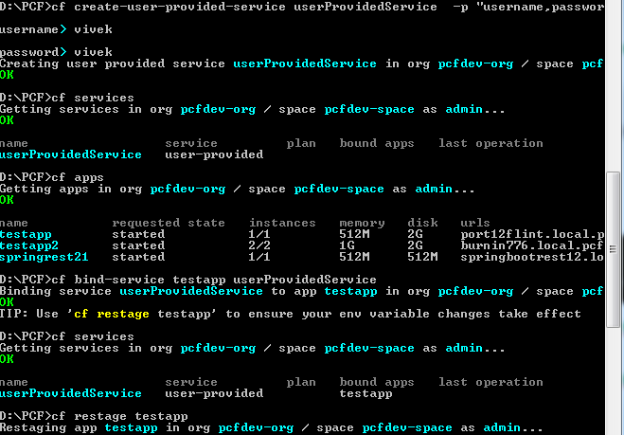
cf create-user-provided-service serviceinstance –p “username,password”|| '{"key1":"value1","key2":"value2"}' || PATH_TO_FILE
Exm: 1) cf create-user-provided-service my-db-mine –p “username,password”
2) cf create-user-provided-service my-db-mine –p /path/to/credentials.json
3)cf create-user-provided-service my-drain-service -l syslog://example.com
4_cf create-user-provided-service my-route-service –r https://example.com
D) How to bind service to app ?
=> cf bind-service app_name service_instance_name
Using add parameter ; cf bind-service app_name service_instance_name -c ‘{“role”,”readonly”}’ || /temp/config.json
E) How to unbind service ?
=> cf unbind-service app_name service_instance_name
Note: You must restart or in some cases re-push your application for changes to be applied to the VCAP_SERVICES environment variable and for the application to recognize these changes.
E) How to deliver service credentials to application?
=> cf cups service_name –p “host,port,dbname,username,password”
F)How to stream application logs to service ?
=> cf cups service-instance_name –l syslog://example.log-aggregator.com
G) How To create a user-provided service instance for a route service, specify the url for the route service using the -r option.
=> cf cups service_instance_name -r https://my-route-service.example.com
Note: When creating the user-provided service, the route service url specified must be https.

I)How to update a user provided service ?
=> use update-user-provided-service || uups
J) what is Service Keys ?
=>Credentials managed manullay are known as “Service keys”. Use service keys when you want a set of credentials for use by clients other than the application in the same space. For instance, you can use service keys to connect to a service instance from a local client, or from an application in another space, or even from outside of Cloud Foundry.
Note: Not all services support service keys. Some services support credentials through application binding only.
##. Service keys are not supported for user-provided service instances.
J)Ho do I manage (create, List, delete, get) Service Keys ?
=> Use the -c flag to provide service-specific configuration parameters in a valid JSON object, either in-line or in a file.
. 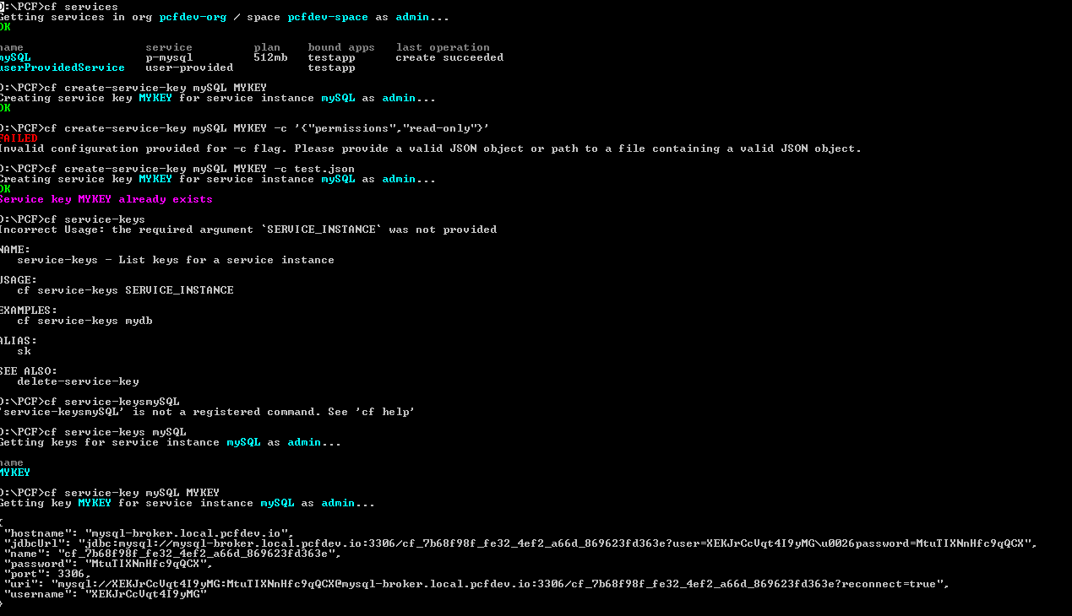
cf create-service-key MY-SERVICE MY-KEY
K)List Service keys for service instance
=> cf service-keys service_instance
L)How to get credentials for service-keys?
=> cf service-key service_instance KEY
M) How to get guid of service Key ?
=> cf service-keys –guid serviceinstance KEYNAME
N)How to delete serviceKey ?
➔ cf delte-service-key servicename KEYNAME
|| cf delte-service-key –f servicename KEYNAME

Q .2 What is the “marketplace”? Does it show all services?
- cf marketplace cf CLI command to view the services available to your targeted organization. Available services may differ between organizations and between Cloud Foundry marketplaces.

